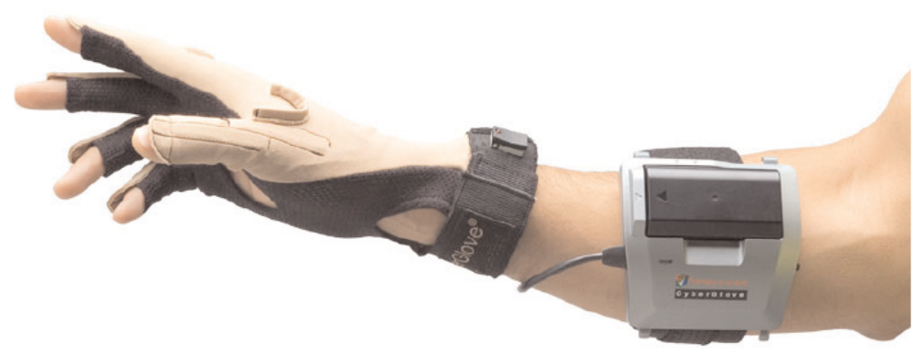

WHEELCHAIR FOR IMPAIRED PEOPLE
Introduction
The design for a WHEELCHAIR FOR IMPAIRED PEOPLE. Utilizing innovative techniques, hand movements translate user input, allowing for a highly intuitive user interface. A wireless transmission system mechanically detaches the operating from the commanding device. The design is successfully implemented and positioned for use in entertainment and scientific sectors.
The WHEELCHAIR FOR IMPAIRED PEOPLE (WIP) was motivated by the need to create a highly intuitive control interface for a variety of applications. While such products currently exist in the market, companies charge upwards of RS25,000 for such devices. In accordance with such, an additional goal of the WIP is to create a cost-effective alternative to virtual reality gloves currently available. By use of various novel sensor configurations, the WIP is capable of representing hand orientation in digital signals. This technology has far-reaching implications. To best demonstrate the range of the glove, we created a highly specialized remote-control robotic car as the controlled subject. This technology has a wide range of applications, from scientific to entertainment. The WIP can easily be implemented in scientific and military explorations of uncharted regions with a variety of remote-controlled devices, including terrestrial, nautical and airborne vehicles. Furthermore, our WIP is an excellent marketable toy; the high degree of control achieved by the glove is sure to provide added enjoyment for any client.
The WIP is composed of three distinct subsystems: vehicle, glove and wireless interface. A block diagram describing these subsystems is shown in Figure 1.

SENSOR
RF TRANSMITTER
RF RECEIVER
Motor
Encoder
Decoder
uC

Relay
Fig 2. Reciver section on robotic wheelchair

Glove:
We use a sleek, lightweight, stylish glove to hold all the sensors and circuitry used to detect different hand positions. This provides the user with a very comfortable method of controlling the vehicle.
Sensors:
Photodiode:
When a photon strikes a semiconductor, it can promote an electron from the valence band (filled orbitals) to the conduction band (unfilled orbitals) creating an electron(-) - hole(+) pair. The concentration of these electron-hole pairs is dependent on the amount of light striking the semiconductor, making the semiconductor suitable as an optical detector. There are two ways to monitor the concentration of electron-hole pairs. In photodiodes, a voltage bias is present and the concentration of light-induced electron-hole pairs determines the current through semiconductor. Photovoltaic detectors contain a p-n junction, that causes the electron-hole pairs to separate to produce a voltage that can be measured.

Schematic of semiconductor detector
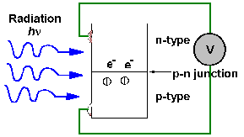
Photodiode detectors are not as sensitive as PMTs but they are small and robust.
Wavelength range
Table 1: Wavelength range
Detector type | Lambda
Si | 0.2 - 1.1
Ge | 0.4 - 1.8
InAs | 1.0 - 3.8
InSb | 1.0 - 7.0
InSb (77K) | 1.0 - 5.6
HgCdTe (77K) | 1.0 -25.0

Tactile micro switch:
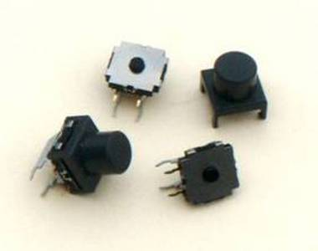
E-Switch has announced the TL6190 - a new, right angle, sealed tactile switch featuring reliable dome technology and a strong tactile force. This process-sealed switch has multiple operating forces and a life expectancy of 100,000 cycles. The TL6190 has nylon housing with a stainless steel cover and comes with a silicone rubber actuator. The TL6190's specifications include: electrical life - 100,000 cycles; operating force - 220 +/- 60gf; contact rating - 50mA @ 12 VDC; contact resistance - 100 milliohms max initial; insulation resistance - 100 Megaohms (Min @ 100V); dielectric strength - 500 VDC; operating temperature - minus 40C to + 85C; and travel - 0.50 +/- 0.20mm.

RF Transmitter
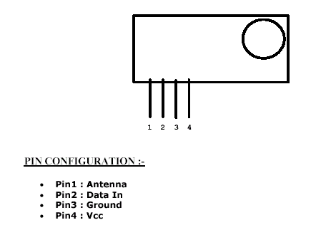
KEY FEATURES :-
• Frequency : 433.92 MHz
• 5 – 12V Single Supply Operational
• OOK / ASK Data Format
• Up to 9.6 kbps data rate
• 4 Pin compact size module
• + 5 dbm out put power ( 12V, Vcc )
• SAW based architect
• Vertical / Horizontal mount
• Directly connect to microcontoller
• Low Power Consumption suitable for battery operated devices
• Direct plug and use
• No external components required
• High performance SAW based Architecture with a maximum range of
100 feet at 4800 bps data rate
• Interface directly to Encoders and Microcontrollers with ease
• Can be directly in your PCB
• Right Angle Pin ( Flat Out ) is the standard in these modules
• Can be used with Fixed Code and Rolling Code Encoders or direct with
Microcontrollers

RF Receiver
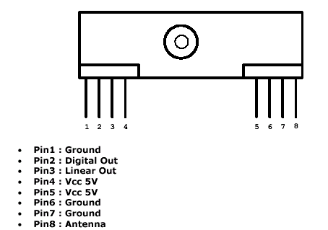
• Miniature Size
• Wide Operating Range
• Low Power Consumption
• Improved Data Transmission
• No Alignment Required
• No External Components PIN Configuration and Size
• Wide Range of Application
• Analogue and Digital Output

Encoder
General Description
The 212 encoders are a series of CMOS LSIs for remote control system applications. They are capable of encoding information which consistsof N address bits and 12_N data bits. Each address/ data input can be set to one of the twologic states. The programmed addresses/data are transmitted together with the header bits via an RF or an infrared transmission medium upon receipt of a trigger signal. The capabilityto select a TE trigger on the HT12E or a DATA trigger on the HT12A further enhances the pplicationflexibility of the 212 series of encoders.
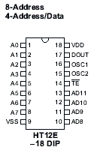
Features
_ Operating voltage
_ 2.4V~5V for the HT12A
_ 2.4V~12V for the HT12E
_ Low power and high noise immunity CMOS technology
_ Low standby current: 0.1_A (typ.) at VDD=5V
_ HT12A with a 38kHz carrier for infrared transmission medium
_ Minimum transmission word
_ Four words for the HT12E
_ One word for the HT12A
_ Built-in oscillator needs only 5% resistor
_ Data code has positive polarity
_ Minimal external components
_ HT12A/E: 18-pin DIP/20-pin SOP package

Decoder
General Description
The 212 decoders are a series of CMOS LSIs for remote control system applications. They are paired with Holtek_s 212 series of encoders (refer
to the encoder/decoder cross reference table).
For proper operation, a pair of encoder/decoder with the same number of addresses and data format should be chosen. The decoders receive serial addresses and data from a programmed 212 series of encoders that
are transmitted by a carrier using an RF or an IR transmission medium. They compare the serial input data three times continuously with their local addresses. If no error or unmatched codes are found, the input data codes are decoded
and then transferred to the output pins. The VT pin also goes high to indicate a valid transmission.
The 212 series of decoders are capable of decoding informations that consist of N bits of address and 12_N bits of data. Of this series, the HT12D is arranged to provide 8 address bits and 4 data bits, and HT12F is used to decode 12
bits of address information.

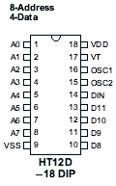

Features
_ Operating voltage: 2.4V~12V
_ Low power and high noise immunity CMOS technology
_ Low standby current
_ Capable of decoding 12 bits of information
_ Pair with Holtek_s 212 series of encoders
_ Binary address setting
_ Received codes are checked 3 times
_ Address/Data number combination
_ HT12D: 8 address bits and 4 data bits
_ HT12F: 12 address bits only
_ Built-in oscillator needs only 5% resistor
_ Valid transmission indicator
_ Easy interface with an RF or an infrared transmission medium
_ Minimal external components

applications:
- for robotic control
- for pc control
- for light, fan, tv control
- for medical surgery
- for military application.

